- The latest UK data error – the undercounting of VAT receipts by HMRC – has further dented our already-low confidence in official statistics. But the forthcoming £2bn upward revision to revenues doesn't meaningfully change the fiscal picture. We expect the Budget on November 26 to tighten fiscal policy by £20bn-£30bn, mainly through tax hikes.
- The Budget will be a key test of market confidence in the government's fiscal approach. Our baseline forecast assumes the government will muddle through and maintain confidence. But if the government missteps and markets take fright, we think that a sharp sterling depreciation would accompany higher gilt yields.
Another week, another data error reported by the Office for National Statistics. But unlike previous errors, the ONS was largely blameless for this one – VAT data supplied by HMRC omitted some payment streams, meaning that receipts have been underestimated by £2bn over the fiscal year to date.
Coming on the back of problems with the labour market, trade, producer prices, inflation, and retail sales releases, the latest episode further erodes our already-low trust in official data. But on the plus side, the new team at the ONS is taking a more open and proactive approach to identifying errors and alerting users than its predecessors.
When the data is corrected in the next public finances release on October 21, it will have only a modest impact on the fiscal situation. The current vintage of the data shows the public sector current budget in deficit by £62bn in the first five months of the fiscal year, £15.3bn higher than the Office for Budget Responsibility's forecast. Reducing that gap by £2bn will still leave borrowing well above where it was expected to be.
We've published a couple of notes this week previewing the Budget on November 26. In the first, we set out how OBR forecast changes will shape the fiscal arithmetic. We expect that the government will have to tighten policy by £20bn-£30bn (0.6%-0.9% of GDP) (Chart 1).
Chart 1: The Budget is likely to tighten fiscal policy by £20bn-£30bn
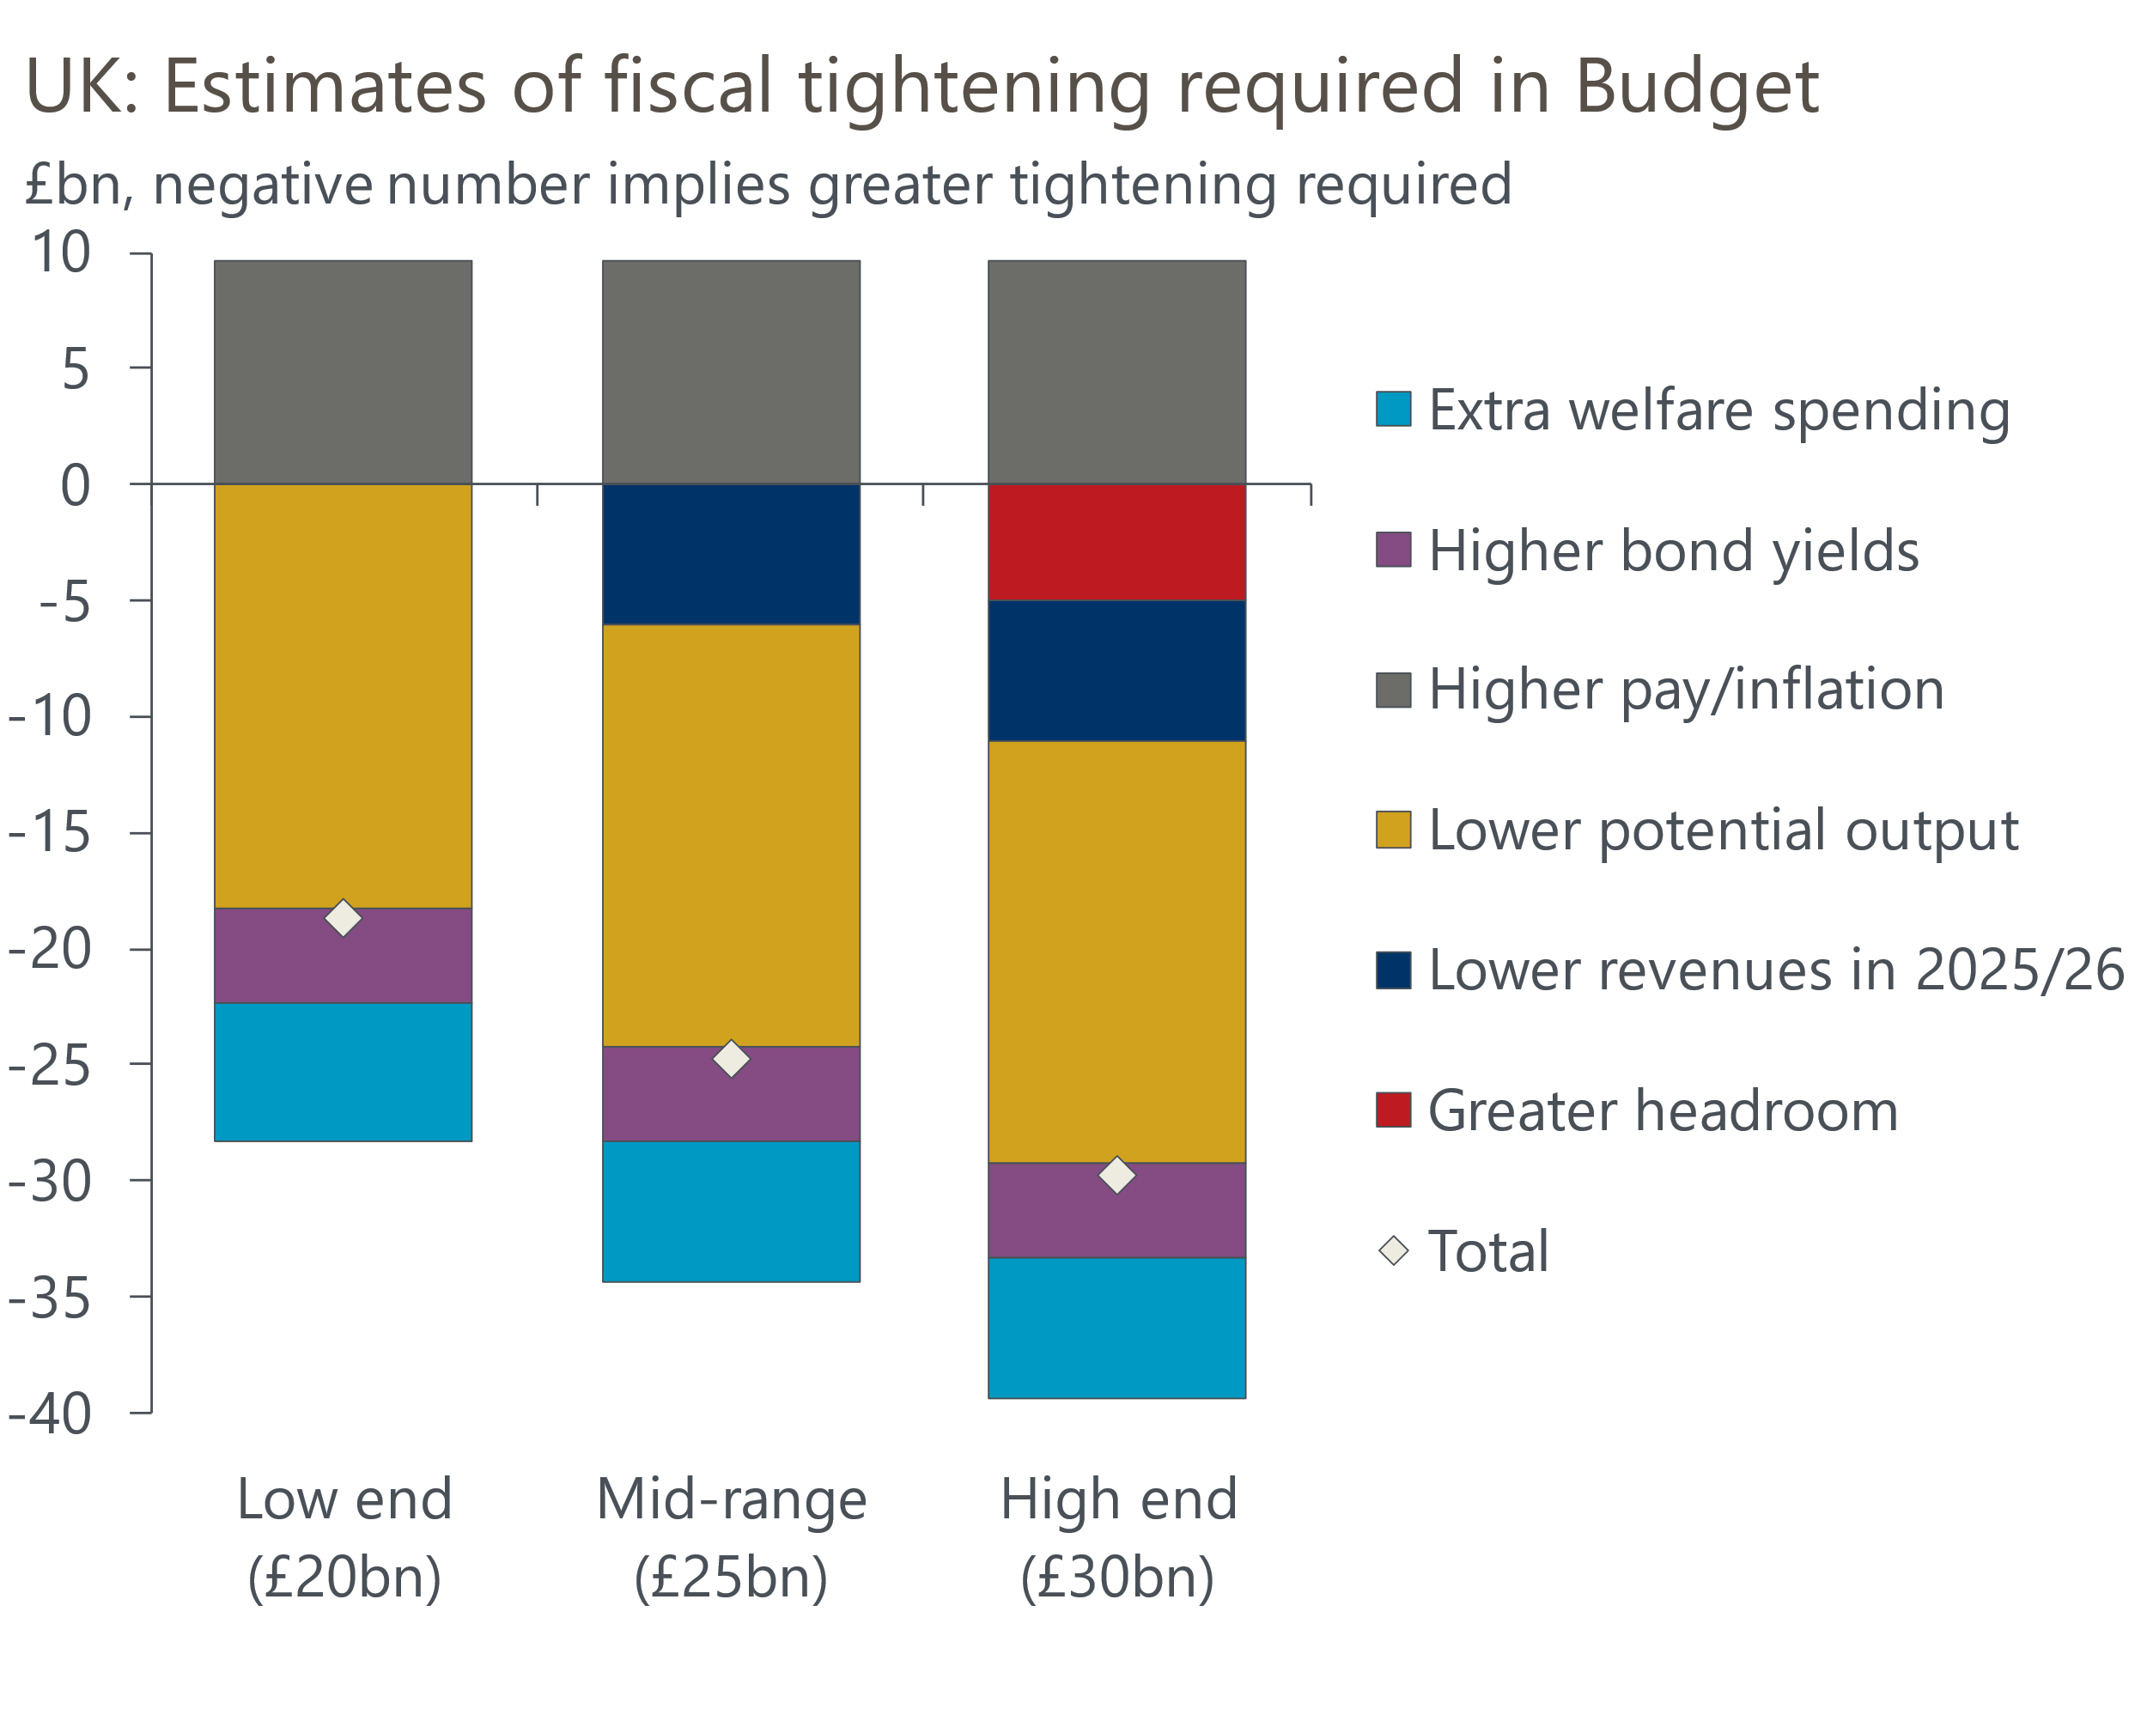
Source: Oxford Economics

Three factors – a downgrade to the OBR's productivity forecast, higher bond yields, and the government's decision to abandon welfare reforms – are set to add around £28bn to borrowing in 2029-2030, the target year for the fiscal rules. But we expect these effects to be mitigated by higher forecasts for pay growth and inflation, which should boost tax receipts.
Then there are two main wild cards to consider, which could together increase the extra tightening required to £30bn. First, will the OBR assume that the weak performance of tax receipts this year carries forward into future years? And second, will the Chancellor learn the lesson of the past two fiscal events and increase the amount of headroom to reduce the risk of being back in this situation again in the near future? We've long backed this idea, and two major bond investors also advocated building a larger buffer in a Financial Times article this week. But given its current unpopularity, the government may decide that the politics of cutting spending or raising taxes to increase headroom don't stack up.
To signal to markets that the government is willing to restrain spending, we expect a small part – £6bn, which is enough to cover costs of the reversals on welfare – will be achieved by spending cuts in the latter part of the forecast period. The remainder will have to come through tax hikes, with the emphasis on broadening the tax base, cutting tax allowances, and increasing 'sin' taxes. We regard a freeze in income tax allowances and NICs thresholds as a near certainty. The extent to which the Chancellor goes down the list, or announces other measures, will depend on the scale of the shortfall identified by the OBR, if the Chancellor seeks to raise headroom, and judgements about the political costs of each measure.
Markets are effectively giving the UK the benefit of the doubt. We think the government will probably 'muddle through' and keep markets onside. But sentiment could turn rapidly if the government missteps. In our second note, we set out how a scenario where markets lose confidence in the UK's fiscal approach might play out.
In our alternative scenario, we think that sterling depreciation would accompany higher gilt yields (Chart 2). A weaker pound would exacerbate the UK's inflation problems and discourage the Monetary Policy Committee from resuming rate cuts in early 2026. We think the government would then belatedly change its fiscal approach, cutting spending to try to restore confidence.
Chart 2: If markets lose faith, sterling could fall sharply alongside higher gilt yields
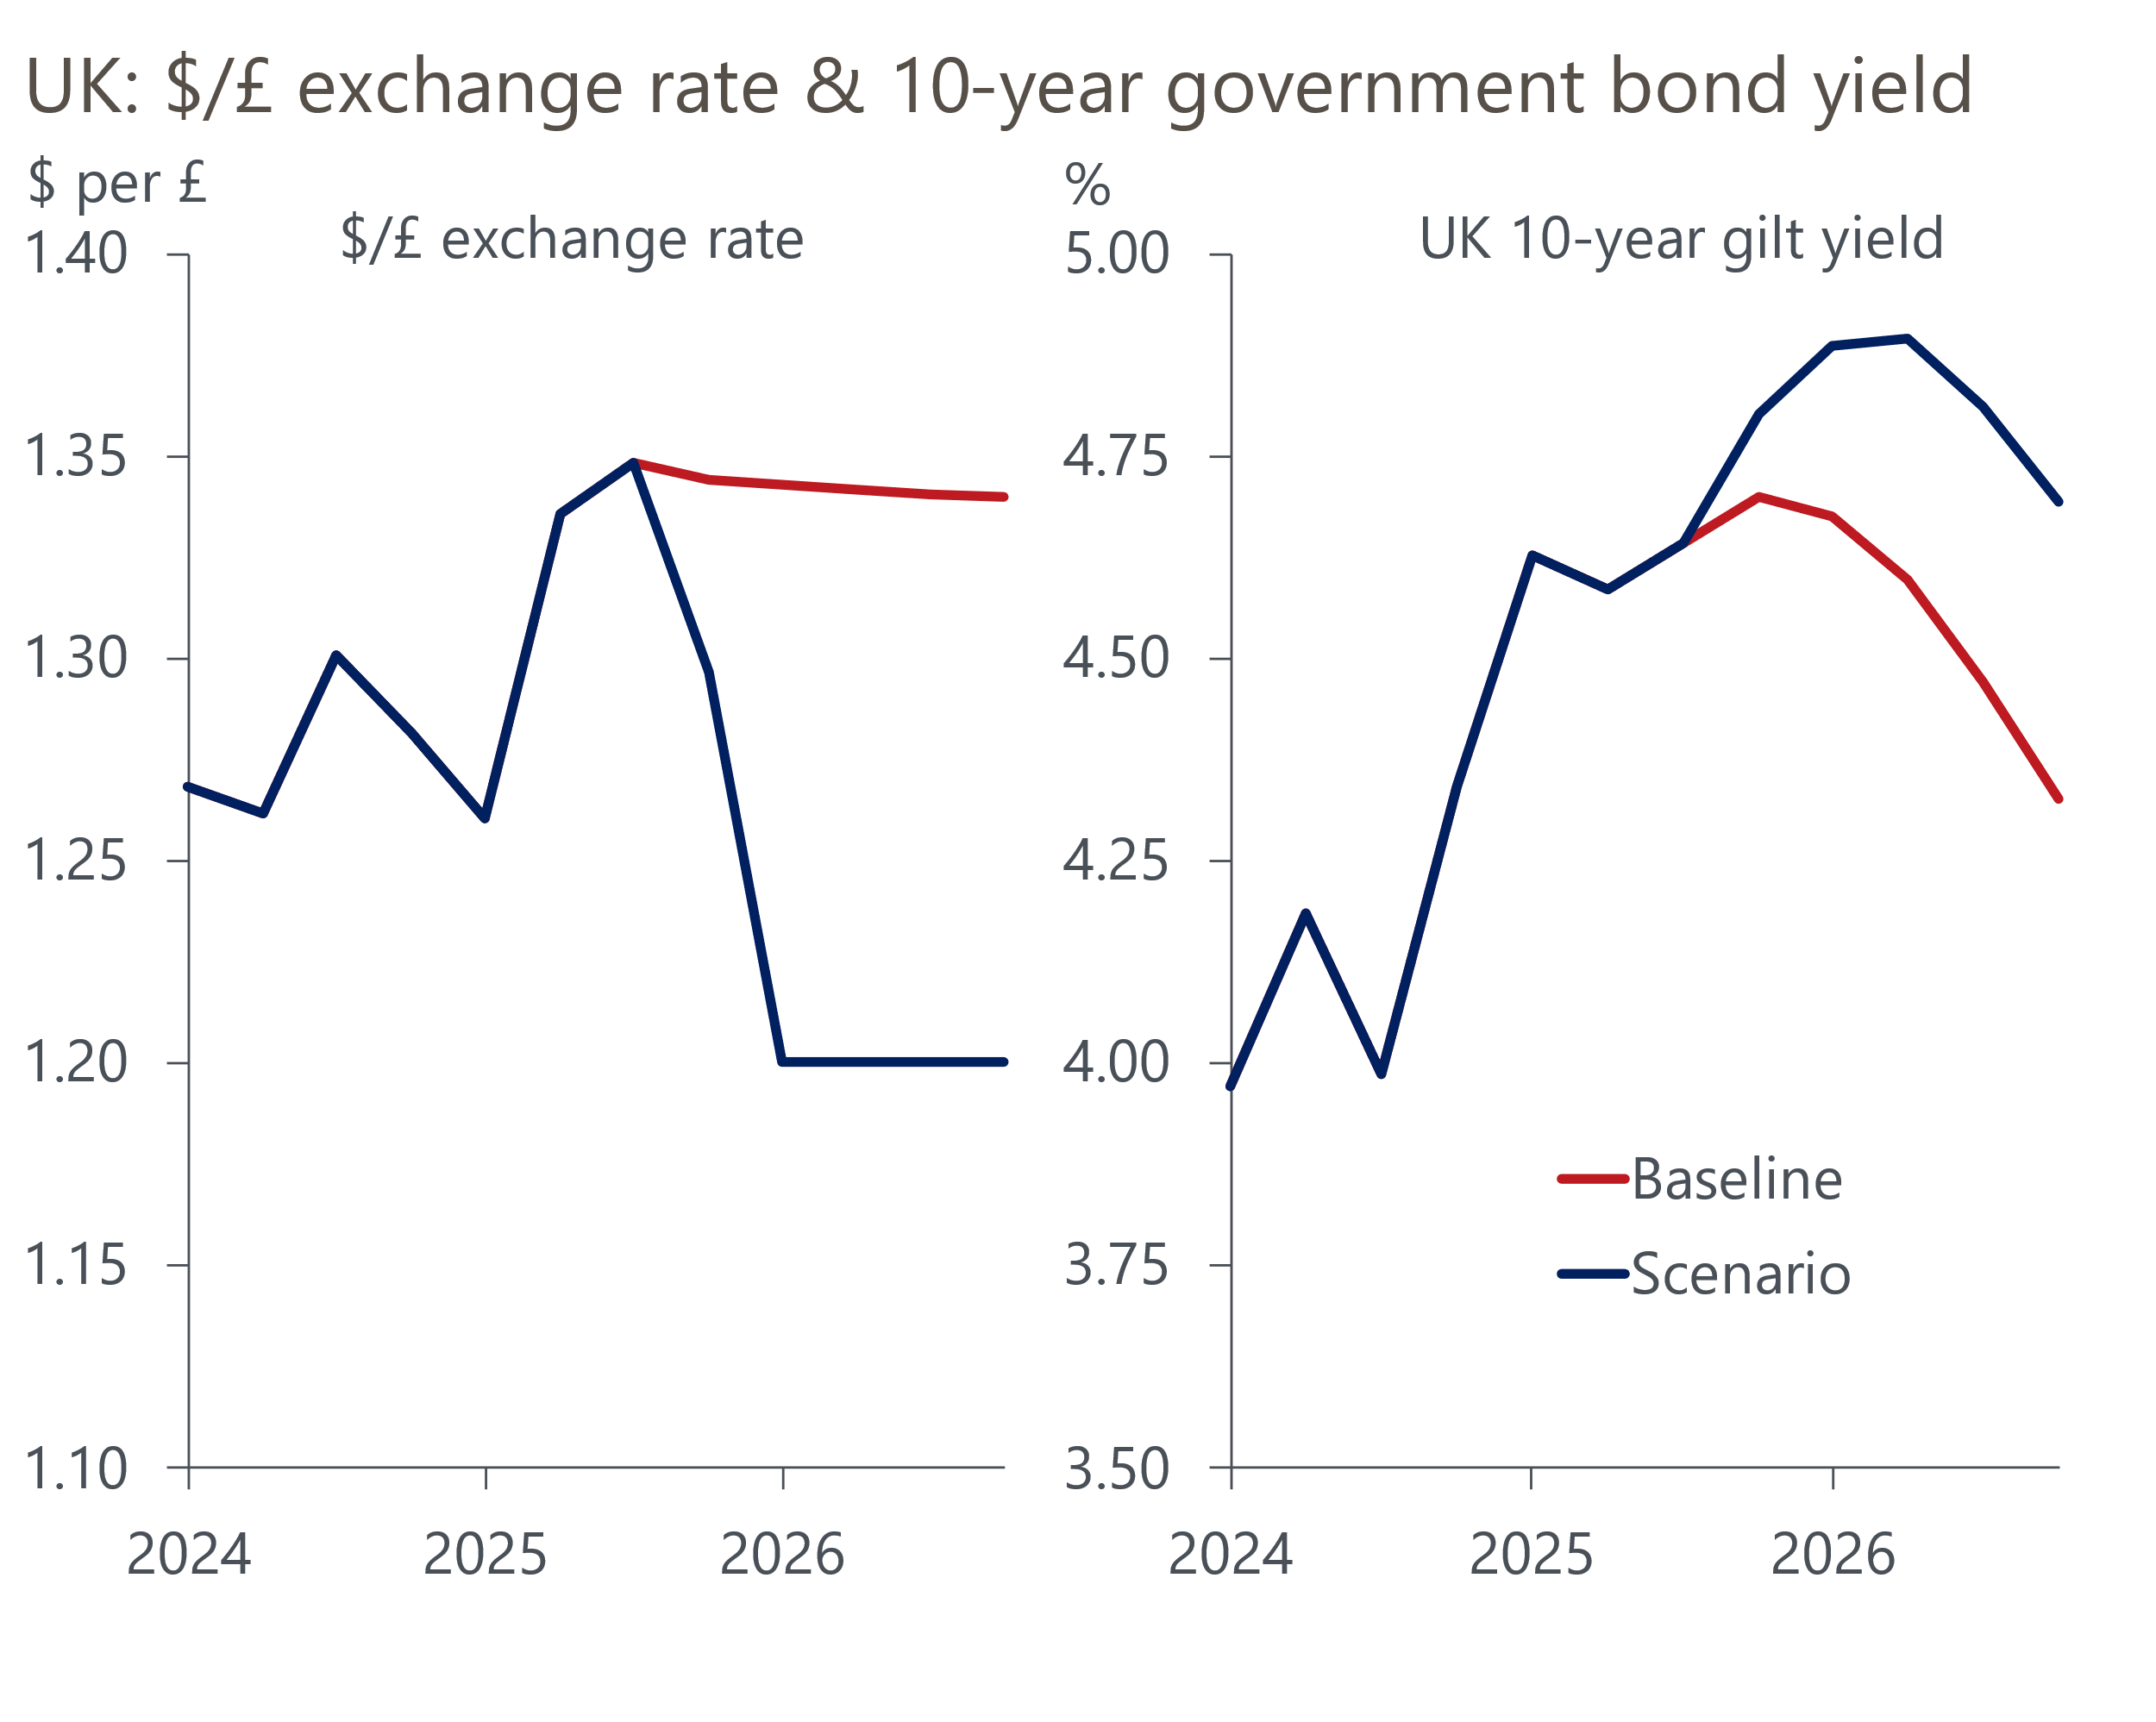
Sources: Oxford Economics, Haver Analytics
Under this scenario, GDP would be 0.6ppts below our baseline forecast by the end of 2027. Consumers would be hit hard, with higher inflation adding to the squeeze on spending power. But the impact of a weaker pound on net trade would mitigate the hit to GDP.
Whether or not this scenario plays out will depend on the choice of measures and their credibility. Revenue-heavy consolidations have a high failure rate, while the behavioural responses from large tax changes may prove greater than expected, and – because those facing large tax hikes may complain vociferously – this strategy may also not be politically viable. The Chancellor is going to be playing a high-stakes game, and success is far from certain.

The week ahead
The first of two major Office for National Statistics releases is the labour market data for the June to August period. Pay growth has been drifting lower through 2025, reflecting a combination of base effects and fading momentum. We expect this process to continue, with headline (three-month average of the annual rate) regular pay growth falling to 4.7% in August. However, the comparison with a volatile period for bonuses last year should temporarily pause the downward momentum behind total pay growth.
Data from the Labour Force Survey remains volatile as the ONS continues to battle low response rates. May's single-month data had shown spikes in both employment and unemployment, but these readings will drop out of the three-month averages in this release. This volatility makes it even harder to predict where the data will fall in August, but we think the most likely outcome is that the unemployment rate holds steady at 4.7%.
Thursday's monthly GDP release will incorporate historical revisions consistent with the recent quarterly national accounts. The indicative monthly profile published alongside the national accounts suggests that the new data will continue to show evidence of residual seasonality. July's release also saw several sub-sectors record very strong outturns that were well above previous trends, suggesting scope for some payback in August. So we pencil in a 0.2% month-on-month fall in GDP in August, though the incorporation of the historical revisions adds more uncertainty than normal.
Table 1: Week ahead calendar
Date | Events | Period | Measure | Unit | Previous | Forecast
Oct 14 | LFS unemployment | Jun-Aug | Rate | % | 4.7 | 4.7
Oct 14 | Average earnings (total pay) | Aug | 3m, y/y | % | 4.7 | 4.8
Oct 14 | Average earnings (regular pay) | Aug | 3m, y/y | % | 4.8 | 4.7
Oct 16 | GDP | Aug | m/m | % | 0.0 | -0.2
Oct 16 | GDP | Aug | 3m/3m | % | 0.2 | 0.3
Oct 16 | Index of services | Aug | m/m | % | 0.1 | -0.1
Oct 16 | Index of services | Aug | 3m/3m | % | 0.4 | 0.4
Oct 16 | Manufacturing output | Aug | m/m | % | -1.3 | 1.0
Oct 16 | Manufacturing output | Aug | y/y | % | 0.2 | -0.8
Oct 16 | Industrial production | Aug | m/m | % | -0.9 | 0.5
Oct 16 | Industrial production | Aug | y/y | % | 0.1 | -0.9
Oct 16 | Construction output | Aug | m/m | % | 0.2 | -0.3
Oct 16 | Construction output | Aug | y/y | % | 2.4 | 1.3
Oct 16 | UK trade | Aug | Trade balance | £bn | -5.3 | -5.0
Oct 16 | UK trade | Aug | Visible balance | £bn | -22.2 | -22.0
Source: Oxford Economics

Key forecasts
Table 2: UK forecast overview
(Annual percentage changes unless specified)
 | 2023 | 2024 | 2025 | 2026 | 2027 | 2028
GDP | 0.3 | 1.1 | 1.5 | 0.9 | 1.3 | 1.7
Private consumption | -0.3 | -0.2 | 1.0 | 1.1 | 1.1 | 1.7
Fixed investment | 0.5 | 1.8 | 2.1 | 0.5 | 1.5 | 2.0
Government consumption | 2.1 | 3.4 | 2.1 | 1.7 | 1.6 | 1.7
Exports of goods and services | -2.3 | 0.7 | 2.9 | -0.2 | 1.2 | 1.5
Imports of goods and services | -1.6 | 2.6 | 3.4 | -0.3 | 1.2 | 1.5
Industrial production | -2.6 | -1.6 | -0.4 | -0.1 | 1.1 | 1.4
Consumer prices | 7.3 | 2.5 | 3.5 | 2.8 | 2.5 | 2.2
Unemployment rate (%) | 4.1 | 4.3 | 4.7 | 4.9 | 4.8 | 4.4
Current a/c balance (% of GDP) | -3.6 | -2.2 | -3.1 | -2.8 | -2.5 | -2.4
Government balance (% of GDP) | 5.2 | 5.1 | 4.7 | 3.7 | 3.1 | 2.7
Central bank policy rate (%, EOP) | 5.25 | 4.75 | 4.00 | 3.50 | 3.00 | 2.75
10yr govt. bond yield (%, EOP) | 3.54 | 4.57 | 4.70 | 4.28 | 3.80 | 3.51
Exchange rate (US$ per £, EOP) | 1.27 | 1.25 | 1.34 | 1.34 | 1.34 | 1.34
Exchange rate (euro per £, EOP) | 1.15 | 1.21 | 1.15 | 1.15 | 1.15 | 1.15
Source: Oxford Economics
Table 3: Quarterly forecasts for the UK
 | 2025 |  |  |  | 2026
 | Q1 | Q2 | Q3 | Q4 | Q1 | Q2 | Q3 | Q4
GDP (% year) | 1.7 | 1.4 | 1.4 | 1.3 | 0.9 | 0.9 | 0.9 | 1.0
CPI inflation (% year) | 2.8 | 3.5 | 3.9 | 3.7 | 3.4 | 2.6 | 2.6 | 2.6
Bank Rate (%, EOP) | 4.50 | 4.25 | 4.00 | 4.00 | 3.75 | 3.75 | 3.50 | 3.50
10yr gilt yield (%, EOP) | 4.70 | 4.48 | 4.70 | 4.70 | 4.69 | 4.58 | 4.44 | 4.28
US$ per £ (EOP) | 1.29 | 1.37 | 1.35 | 1.34 | 1.34 | 1.34 | 1.34 | 1.34
Euro per £ (EOP) | 1.20 | 1.17 | 1.15 | 1.15 | 1.15 | 1.15 | 1.15 | 1.15
Source: Oxford Economics

Latest Country Economic Forecast:
September 16, 2025

Recent publications

Data Insights
Services sector vulnerable to the Budget uncertainty
Manufacturing sector remains fragile
GDP growth hides more weakness
The recovery in mortgage demand stumbled in August
PMI confirms sluggish growth outlook

Research Briefings
What happens if markets lose faith in the fiscal approach?
What will the Chancellor do in the Budget?
Fiscal fragility could reveal sterling's vulnerability
MPC follows path of least resistance on quantitative tightening
MPC preview – Pace and shape of QT is likely to be tweaked

Contacts

Oxford Economics' UK team
- Andrew Goodwin - Chief UK Economist - agoodwin@oxfordeconomics.com
- Edward Allenby - Senior UK Economist - eallenby@oxfordeconomics.com

